AUGUST, 2015

To change from Quarter Grade to Mid-Term Grade; Semester Grade; Semester Test (only need when posting mid-term grades or semester grades)

To add a new assignment / task

To change classes

To change quarters

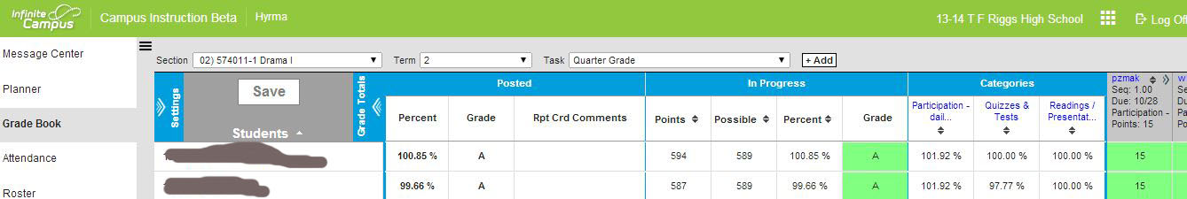

Expand to mark assignment “turned in”, “missing”, etc.

The arrows will show/hide the grade calculations to just show assignment scores.

The arrows will show/hide the settings screen and options.

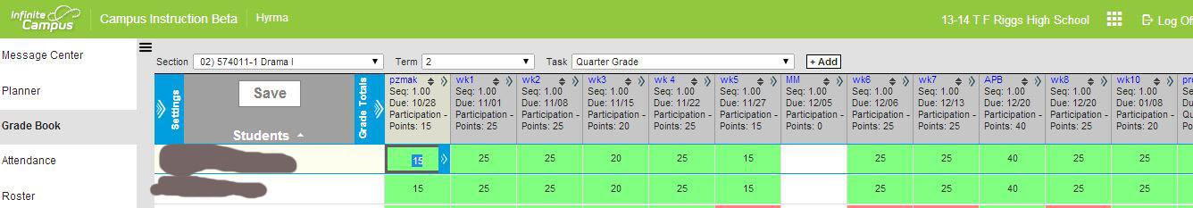

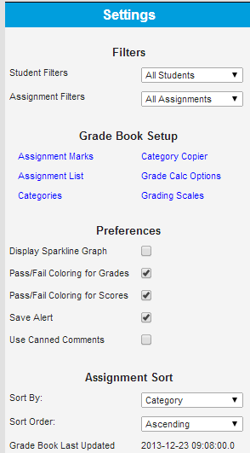  
(more detailed description on page 2)

|  |  |
| --- | --- |
|  | 1. Filters.    * Student Filters - allows the grade book display to be filtered to a specific student group or student. This is helpful when viewing a particular student group's scores or in individual student's (ex. student conference).    * Assignment Filters - allow the grade book to be filtered to a specific assignment. This is helpful when entering scores for a specific assignment. 2. Preferences.    * Display Sparkline Graph - determines whether or not a sparkline graph for point/mark based scoring or a bar chart for rubric-based scoring appears next to student names. For more information about sparkline graphs and rubric bar charts, click [here](https://community.infinitecampus.com/kb/display/ICCS/View+Student+Score+Trends).    * Pass/Fail Coloring for Grades - this turns the visual pass/fail color coding on and off for In Progress and Posted Grades within the Grade Book.    * Pass/Fail Coloring for Scores - this turns the visual pass/fail color coding on and off for assignments within the Grade Book.    * Save Alert - determines whether or not the user will be notified when the Grade Book is saved after clicking Save.    * Used Canned Comments -  this allows users to select from a list of district/school specific grading comments. 3. Assignment Sort Options.    * Sort By - this controls how assignments are displayed. Users can choose to sort assignments by Sequence, End Date, then Name, or to sort them primarily by Category, then Sequence, End Date and Name.    * Sort Order - this determines the order in which assignments appear in the Grade Book - ascending or descending. Ascending will display assignments oldest to newest. Descending will display assignments newest to oldest. 4. When finished, click the Settings toggle. |